Photography Composition Assignment
DIRECTIONS
Take 3 good photos (inside school) of each of the 7 Photography Composition Rules. You will have a total of 21 photos.

Rule of Thirds
Imagine that your image is divided into 9 equal segments by 2 vertical and 2 horizontal lines. The rule of thirds says that you should position the most important elements in your scene along these lines, or at the points where they intersect.
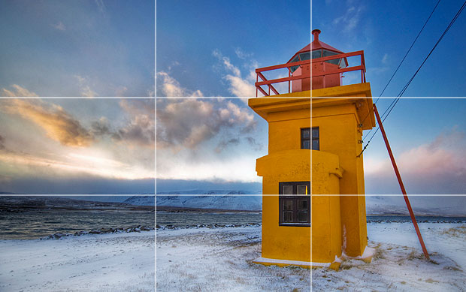

Leading Lines
When we look at a photo our eye is naturally drawn along lines. By thinking about how you place lines in your composition, you can affect the way we view the image, pulling us into the picture, towards the subject, or on a journey "through" the scene. There are many different types of line - straight, diagonal, curvy, zigzag, radial etc - and each can be used to enhance our photo's composition.

Filling the Frame
The simple act of making your subject bigger in the frame involves the viewer at a much more intense level. A chin-to-forehead portrait of an interesting face, for example, immediately puts the viewer eye-to-eye with your subject. A very tight shot of a bear—even if you made it with a long lens at the zoo—creates breathless drama.
Pattern (Repetition)
We are surrounded by symmetry and patterns, both natural and man-made. They can make for very eye-catching compositions, particularly in situations where they are not expected.
Framing
The world is full of objects which make perfect natural frames, such as trees, archways and holes. By placing these around the edge of the composition you help to isolate the main subject from the outside world. The result is a more focused image which draws your eye naturally to the main point of interest.
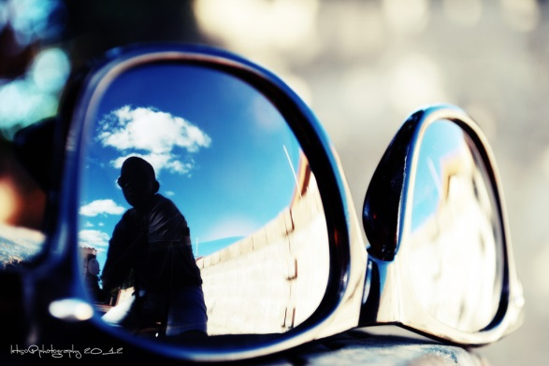
Symmetry
Just like patterns, we are surrounded by symmetry, both natural and man-made. They can make for very eye-catching compositions, particularly in situations where they are not expected.
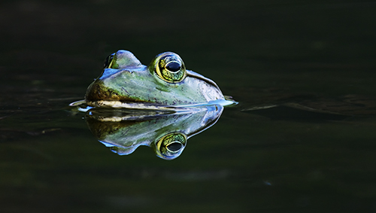

Center the Eye
Centering the eye gives the impression that the eye is following you.
